TABLE 1: Reasons for Returned Medications and Frequency of Return

|  |  |  |
| --- | --- | --- |
| Reason for Refund | Frequency | Percentage |
| DRUG UNUTILIZED AT TIME OF DISCHARGE | 73 | 45.06% |
| DEMISE OF THE PATIENT | 34 | 20.99% |
| DRUG NOT AVAILABLE AFTER PAYMENT | 31 | 19.14% |
| CHANGE OF DRUG REGIMEN | 23 | 14.20% |
| PATIENT INSISTED ON A BRAND NOT AVAILABLE | 1 | 0.62% |

CHART 1: Reasons for Returns in Accident and Emergency Pharmacy

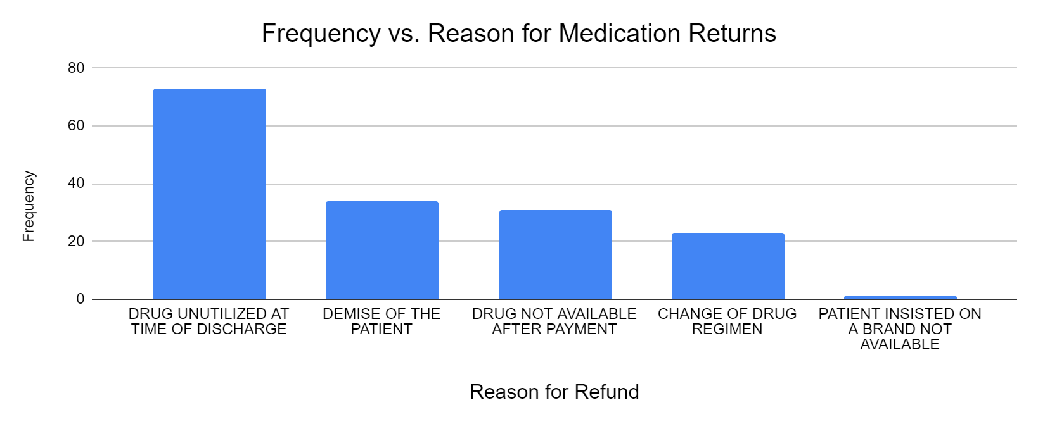

TABLE 2: Top 30 returned medications in Accident and Emergency Pharmacy

|  |  |  |
| --- | --- | --- |
| Medications | Total Quantity Returned | Frequency |
| SYRINGES | 277 | 15.52% |
| NORMAL SALINE | 160 | 8.96% |
| WATER FOR INJECTION | 141 | 7.90% |
| IV CANNULA | 66 | 3.70% |
| TABS METRONIDAZOLE 200MG | 63 | 3.53% |
| INJ. CEFTRIAXONE | 60 | 3.36% |
| TABS AMILORIDE/HYDROCHLORTHIAZIDE | 60 | 3.36% |
| INJ. PARACETAMOL | 57 | 3.19% |
| NORMAL SALINE | 55 | 3.08% |
| INJ. METRONIDAZOLE | 51 | 2.86% |
| INJ. FRUSEMIDE | 49 | 2.75% |
| TABS. DIHYDROCODEINE | 46 | 2.58% |
| TABS. DICLOFENAC | 40 | 2.24% |
| TABS. TIZANIDINE 2MG | 40 | 2.24% |
| 5% DEXTROSE SALINE | 32 | 1.79% |
| TABS. ROSUVASTATIN 10MG | 30 | 1.68% |
| TABS NIFEDIPINE 30 XL | 30 | 1.68% |
| TABS GABAPENTIN & METHYLCOBALAMIN | 30 | 1.68% |
| INJ. OMEPRAZOLE | 28 | 1.57% |
| 5% DEXTROSE WATER | 24 | 1.34% |
| TABS CETIRIZINE | 20 | 1.12% |
| CAPS. AMPICILLIN/ CLOXACILLIN | 20 | 1.12% |
| 10% DEXTROSE WATER | 19 | 1.06% |
| INJ. CEFTRIAXONE/SULBACTAM | 18 | 1.01% |
| FEEDING TUBE | 15 | 0.84% |
| INJ. CIPROFLOXACIN | 15 | 0.84% |
| INJ. DICLOFENAC | 15 | 0.84% |
| TAB AMLODIPINE 10MG | 15 | 0.84% |
| TABS ORNIDAZOLE/OFLOXACIN | 14 | 0.78% |
| TABS. AMOXICILLIN/CLAVULANIC ACID | 14 | 0.78% |
|  |  |  |

TABLE 3: Total cost of medications returned in each month

|  |  |  |
| --- | --- | --- |
| **Months** | **Amount per month** | **Number of Returns** |
| Aug, 23 | ₦155,700 | 40 |
| Sept, 23 | ₦114,380 | 36 |
| Oct, 23 | ₦185,040 | 43 |
| Nov, 23 | ₦185,810 | 57 |
| Dec, 23 | ₦316,090 | 92 |
| Jan, 24 | ₦371,090 | 79 |
| Feb, 24 | ₦331,570 | 65 |
| Mar, 24 | ₦215,960 | 38 |
| April, 24 | ₦264,200 | 52 |
| May, 24 | ₦152,710 | 27 |

Chart 2: Monthly Returns and Cost of returned medications in each month

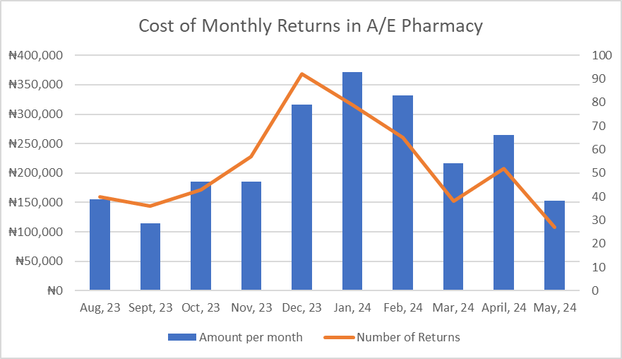

Overall Report for medication returns in A/ E 10 months

|  |  |
| --- | --- |
| Variable |  |
| Total Returns | 529 |
| Total Cost of Returns | ₦2,292,550 |
| Total medications returned | 1785 |
| Average cost of Returns per month | ₦229,255 |
| Average Returns per month | 53 |

TABLE 4: Class of medications and quantity returned

|  |  |
| --- | --- |
| Class | Quanatity Returned |
| Consumables | 596 |
| Antibiotics | 324 |
| Electrolyte Replacement Fluids | 281 |
| Analgesics | 264 |
| Cardiovascular Drugs | 151 |
| Diuretic injections | 49 |
| GastroIntestinal Drugs | 32 |
| Others | 24 |
| Antimalarials | 23 |
| CNS agents | 20 |
| Corticosteriod injections | 12 |
| Hemostatic agents | 8 |
| Multivitamin | 1 |